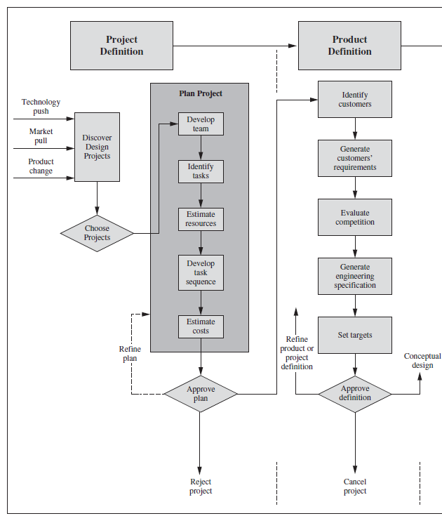
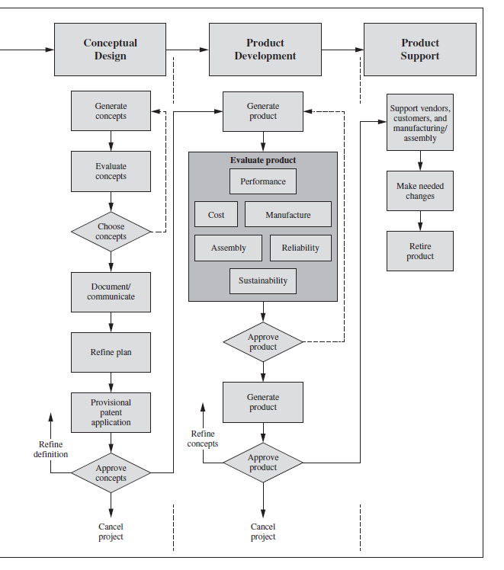
An Overview of the mechanical design and product support process. The Mechanical Design Process 6th edition, David G. Ullman

